Name: Anirban Das Batch: BCSE-II Session: 2020-21
Roll No.: 001910501077
Second Semester Experiments in Microprocessor Lab

Problem Sheet #2

1. Two numbers MN H and KL H are stored in 2050 H and 2051 H , respectively. Write a program to assemble them as NK H and LM H store them in 2052 H and 2053 H .

Line# | Address in Hex | Label | Instruction | Opcode (in hex) | Remarks
1 | 0800 |  | LDA 2200H | 3A | A = M[2050H]
2 | 0801 |  | LDA 2200H | 50 | A = M[2050H]
3 | 0802 |  | LDA 2200H | 20 | A = M[2050H]
4 | 0803 |  | MOV B, A | 47 | B = A
5 | 0804 |  | ANI 0FH | E6 | A = A AND 0FH
6 | 0805 |  | ANI 0FH | 0F | A = A AND 0FH
8 | 0807 |  | RLC | 07 | Shift LEFT 4 times to bring them down to lower signficant position for addition
8 | 0808 |  | RLC | 07
8 | 0809 |  | RLC | 07
8 | 080A |  | RLC | 07
9 | 080B |  | MOV C,A | 4F | C = A
11 | 080C |  | MOV A,B | 78 | A = B
13 | 080D |  | ANI F0H | E6 | A = A AND F0H
13 | 080E |  | ANI F0H | F0 | A = A AND F0H
14 | 080F |  | RLC | 07 | Shift LEFT 4 times to bring them down to lower signficant position for addition
14 | 0810 |  | RLC | 07
14 | 0811 |  | RLC | 07
14 | 0812 |  | RLC | 07
17 | 0813 |  | MOV D,A | 57 | Halt
18 | 0814 |  | LDA 2051H | 3A | A = M[2050H]
18 | 0815 |  | LDA 2051H | 51 | A = M[2050H]
18 | 0816 |  | LDA 2051H | 20 | A = M[2050H]
21 | 0817 |  | MOV B,A | 47 | B = A
22 | 0818 |  | ANI 0FH | E6 | A = A AND 0FH
22 | 0819 |  | ANI 0FH | 0F | A = A AND 0FH
24 | 081A |  | RLC | 07 | Shift LEFT 4 times to bring them down to lower signficant position for addition
24 | 081B |  | RLC | 07
24 | 081C |  | RLC | 07
24 | 081D |  | RLC | 07
25 | 081E |  | MOV E,A | 5F | E = A
26 | 081F |  | MOV A,B | 78 | A = B
27 | 0820 |  | ANI F0H | E6 | A = A AND F0H
27 | 0821 |  | ANI F0H | F0 | A = A AND F0H
29 | 0822 |  | RLC | 07 | Shift LEFT 4 times to bring them down to lower signficant position for addition
29 | 0823 |  | RLC | 07
29 | 0824 |  | RLC | 07
29 | 0825 |  | RLC | 07
33 | 0826 |  | MOV H,A | 47 | B = A
34 | 0827 |  | MOV A,C | 79 | A = C
35 | 0828 |  | ADD H | 84 | A = A + H
36 | 0829 |  | STA 2052H | 32 | Store to required target address
36 | 082A |  | STA 2052H | 52 | Store to required target address
36 | 082B |  | STA 2052H | 20 | Store to required target address
39 | 082C |  | MOV A,D | 7A | A = D
40 | 082D |  | ADD E | 83 | A = A + E
41 | 082E |  | STA 2053H | 32 | Store to required target address
41 | 082F |  | STA 2053H | 53 | Store to required target address
41 | 0830 |  | STA 2053H | 20 | Store to required target address
44 | 0831 |  | HLT | 76 | Halt

Simulator with loaded machine code:
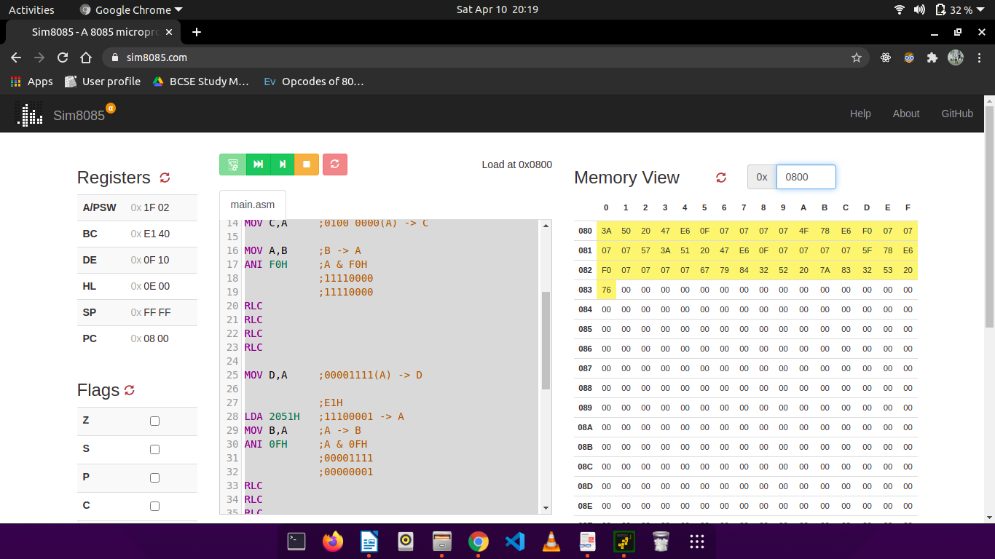

Sample input and output (M[2050] = F4H, M[2051] = E1H => M[2052] = 4EH, M[2053] = 1FH):
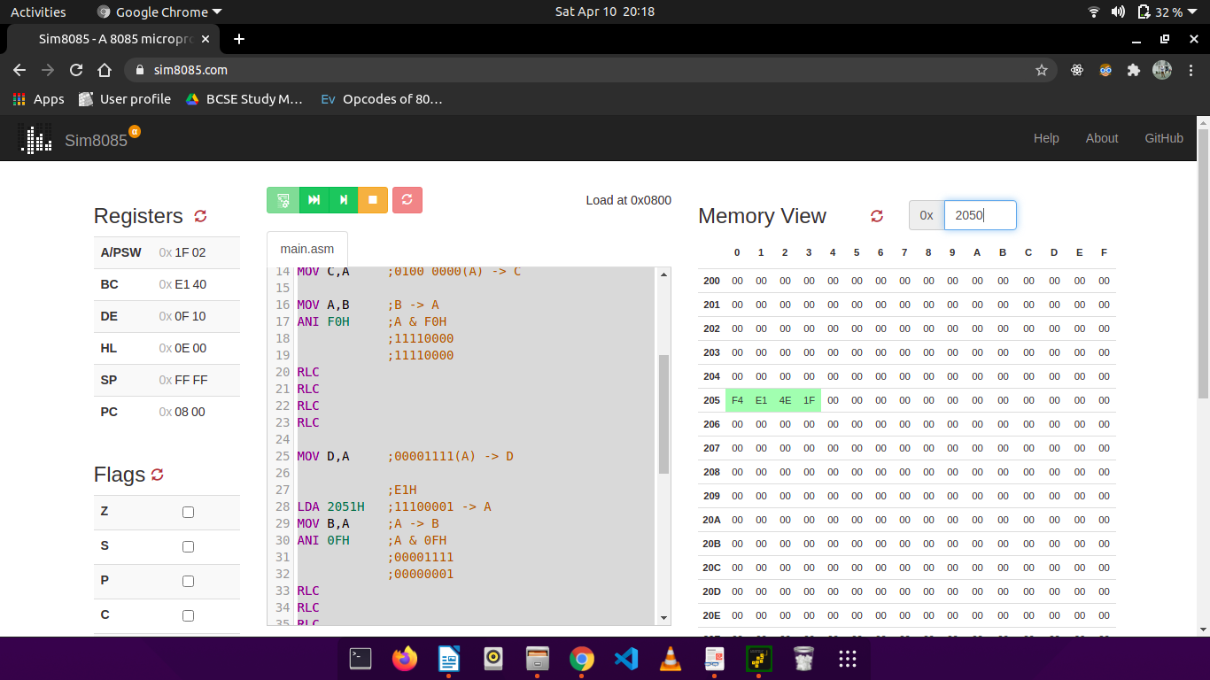
2. Two numbers A & B are stored in 2050 H and 2051 H , respectively. Write a program to perform A×B and store the result in 2052 H and 2053 H .

Line# | Address in Hex | Label | Instruction | Opcode in Hex | Remarks
01 | 0800 |  | LHLD 2050H | 2A | H = M[2050H] L = M[2051H]
02 | 0801 |  | LHLD 2050H | 50 | H = M[2050H] L = M[2051H]
03 | 0802 |  | LHLD 2050H | 20 | H = M[2050H] L = M[2051H]
04 | 0803 |  | XCGH | EB | D = H & E = L
05 | 0804 |  | MOV C,D | 4A | C = D
06 | 0805 |  | MVI D,00H | 16 | D = 00H
06 | 0806 |  | MVI D,00H | 00 | D = 00H
08 | 0807 |  | LXI H, 0000H | 21 | H = 00H & L = 00H
08 | 0808 |  | LXI H, 0000H | 00 | H = 00H & L = 00H
08 | 0809 |  | LXI H, 0000H | 00 | H = 00H & L = 00H
11 | 080A | LOOP: | DAD D | 19 | HL = HL + DE
12 | 080B |  | DCR C | 0D | C = C-1
13 | 080C |  | JNZ LOOP | C2 | Repeat the process until C becomes 0.
13 | 080D |  | JNZ LOOP | 0A | Repeat the process until C becomes 0.
13 | 080E |  | JNZ LOOP | 08 | Repeat the process until C becomes 0.
16 | 080F | SKIP: | SHLD 2052H | 22 | Store at required address.
16 | 0810 | SKIP: | SHLD 2052H | 52 | Store at required address.
16 | 0811 | SKIP: | SHLD 2052H | 20 | Store at required address.
19 | 0812 |  | HLT | 76 | Halt

Simulator with loaded machine code:

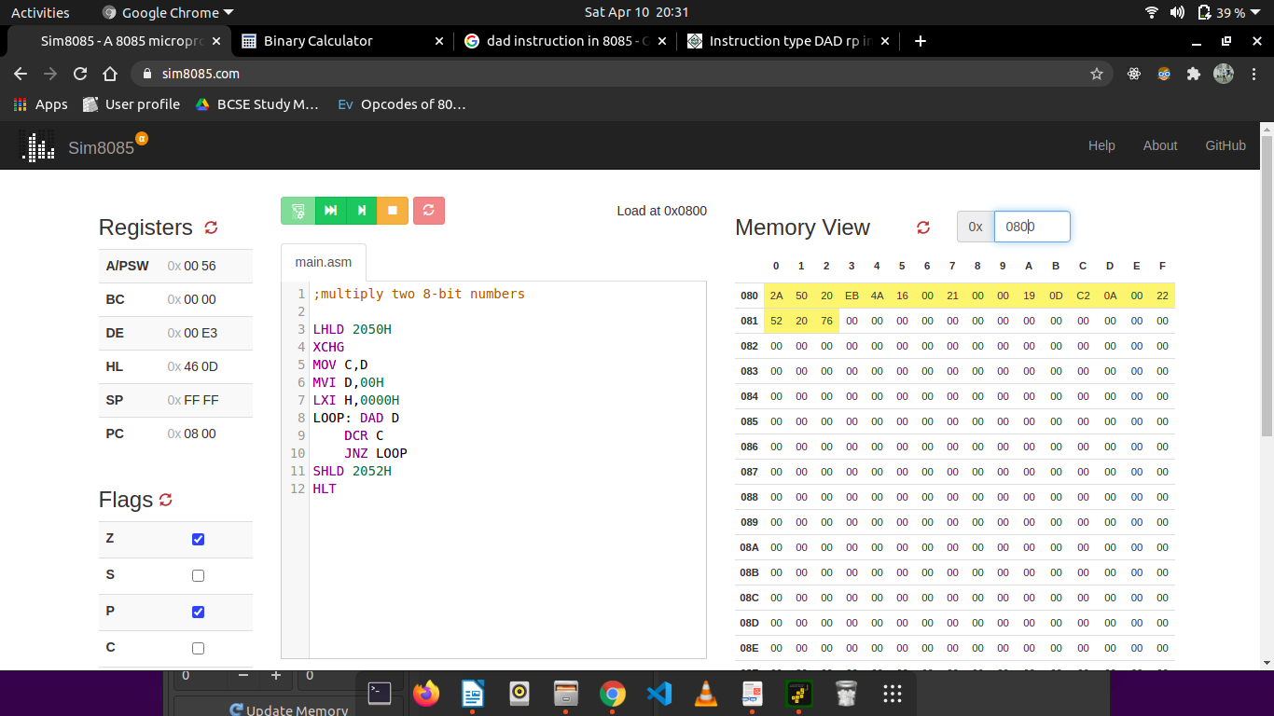
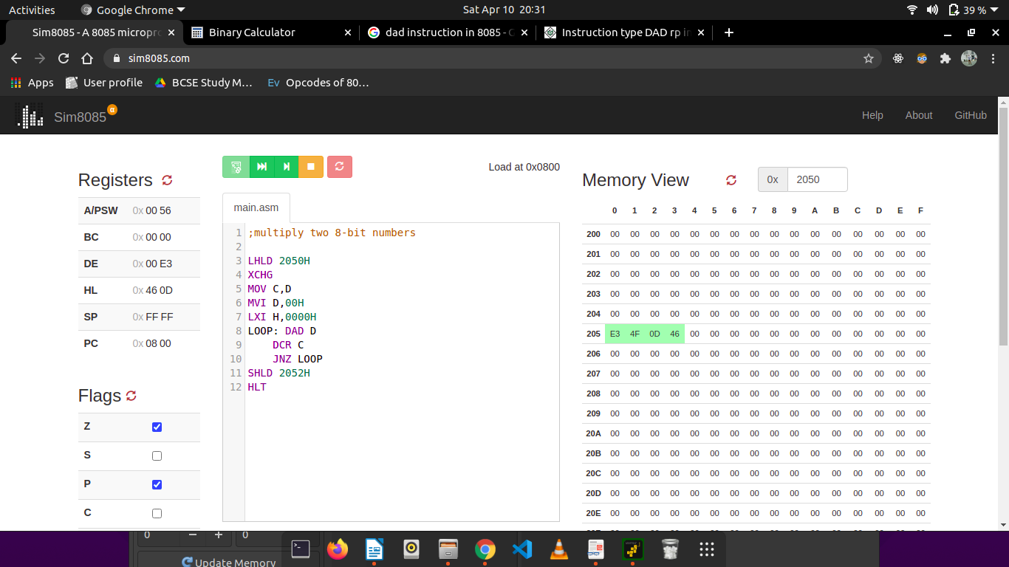
Sample input and output (M[2050] = E3, M[2051] = 4F => M[2052] = 0D, M[2053] = 46):

3. N numbers are stored in consecutive m/m location starting from 2050 H . The value N is stored in 204F H .

a) Find the maximum and minimum among the N numbers.

Line# | Address in Hex | Label | Instruction | Opcode in Hex | Remarks
1 | 0800 |  | LXI H, 204FH | 21 | Get value of N
2 | 0801 |  | LXI H, 204FH | 4F | Get value of N
3 | 0802 |  | LXI H, 204FH | 20 | Get value of N
4 | 0803 |  | MOV D,M | 56 | D = M
5 | 0804 |  | LXI H, 2050H | 21 | Get address of first list element
6 | 0805 |  | LXI H, 2050H | 50 | Get address of first list element
6 | 0806 |  | LXI H, 2050H | 20 | Get address of first list element
8 | 0807 |  | MOV B,M | 46 | Initialize Max register
9 | 0808 |  | MOV C,M | 4E | Initialize Min register
10 | 0809 | MAX | MOV A,M | 7E | Get higher significant 4 bits
11 | 080A |  | CMP B | B8 | A - B
12 | 080B |  | JC MIN | DA | Jump to MIN if Cy = 1
12 | 080C |  | JC MIN | 0F | Jump to MIN if Cy = 1
12 | 080D |  | JC MIN | 08 | Jump to MIN if Cy = 1
15 | 080E |  | MOV B,A | 47 | Store current value as if MAX if no carry.
16 | 080F | MIN | CMP C | B9 | A - C
17 | 0810 |  | JNC SKIP | D2 | Jump to SKIP if element is smaller than Accumulator (Cy=0) .
17 | 0811 |  | JNC SKIP | 14 | Jump to SKIP if element is smaller than Accumulator (Cy=0) .
17 | 0812 |  | JNC SKIP | 08 | Jump to SKIP if element is smaller than Accumulator (Cy=0) .
20 | 0813 |  | MOV C,A | 4F | Else store element as MIN
21 | 0814 | SKIP | INX H | 23 | Go to next address
22 | 0815 |  | DCR D | 15 | Decrement N
23 | 0816 |  | JNZ MAX | C2 | Continue the process until N=0
23 | 0817 |  | JNZ MAX | 09 | Continue the process until N=0
23 | 0818 |  | JNZ MAX | 08 | Continue the process until N=0
26 | 0819 |  | LXI H,2200H | 21 | Load the required address
26 | 081A |  | LXI H,2200H | 00 | Load the required address
26 | 081B |  | LXI H,2200H | 22 | Load the required address
29 | 081C |  | MOV M,B | 70 | M = max of list = B
30 | 081D |  | MOV A,C | 79 | A = min of list = C
31 | 081E |  | STA 2202H | 32 | Store at required address
31 | 081F |  | STA 2202H | 02 | Store at required address
31 | 0820 |  | STA 2202H | 22 | Store at required address
34 | 0821 |  | HLT | 76 | Halt

Simulator with loaded machine code:

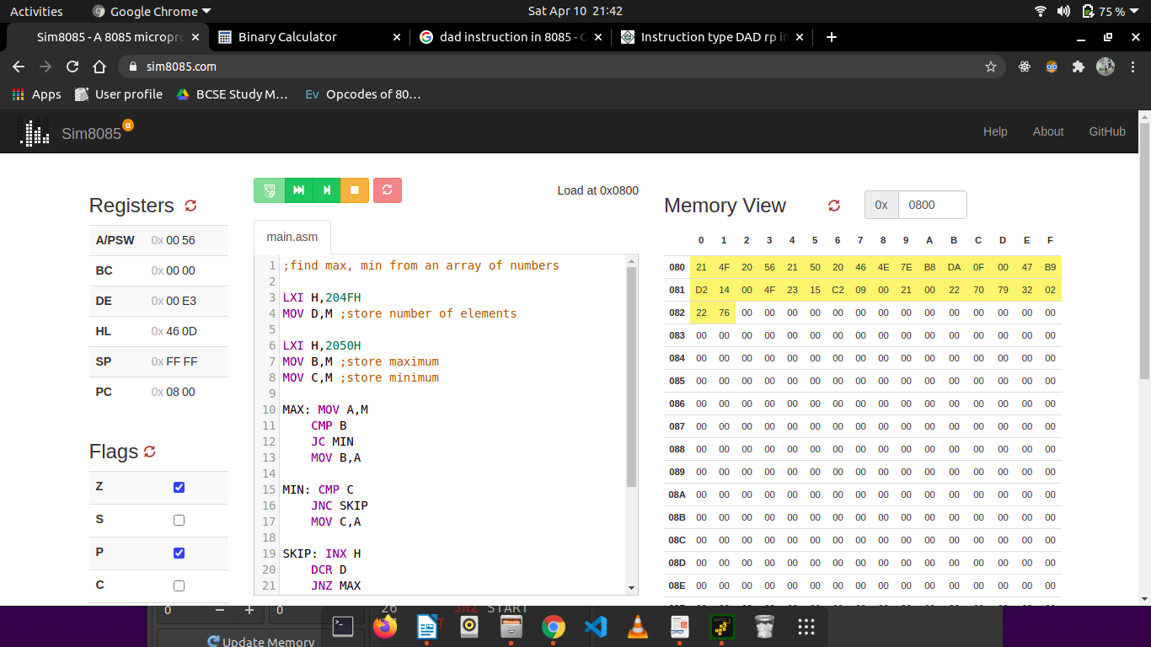

Sample input and output (M[204F] = 05H, M[2050] = 01H, M[2051] = 15H, M[2052] = 05H, M[2053] = 36H, M[2054] = F0H => M[2200] = F0H, M[2202] = 01H):
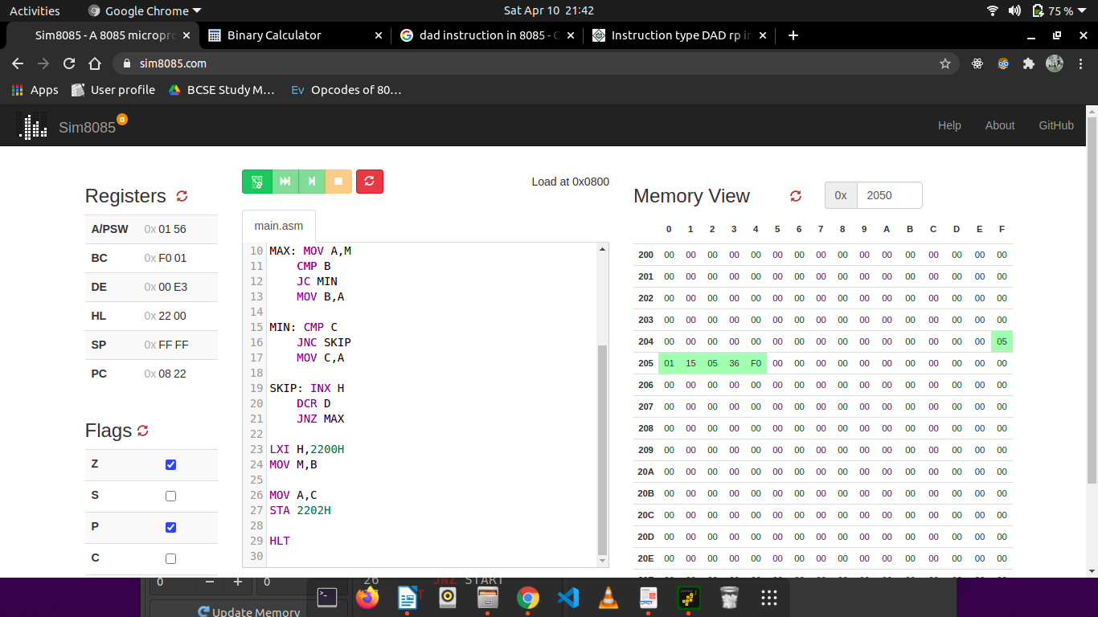

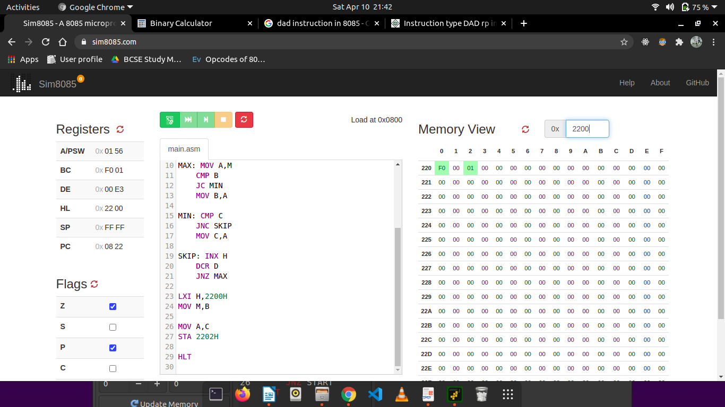

b) Sort the N numbers in ascending and descending order.

Line# | Address in Hex | Label | Instruction | Opcode in Hex | Remarks
1 | 0800 | START | MVI D, 00H | 16 | D = 00H
2 | 0801 |  | MVI D, 00H | 00 | D = 00H
3 | 0802 |  | LXI H, | 21 | D = M
3 | 0803 |  | LXI H, | 4F | D = M
3 | 0804 |  | LXI H, | 20 | D = M
6 | 0805 |  | MOV B,M | 46 | Store count from the list.
7 | 0806 |  | DCR B | 05 | D = D - 1
8 | 0807 |  | INX H | 23 | Go to next address
9 | 0808 | PREVIOUS | MOV A,M | 7E | A = M
10 | 0809 |  | INX H | 23 | Go to next address
11 | 080A |  | CMP M | BE | A = A - M
12 | 080B |  | JC NEXT /  JNC NEXT | DA / D2 | Jump TO NEXT if Cy=1 -> ASCENDING  OR  Jump to NEXT if Cy = 0 -> DESCENDING
12 | 080C |  | JC NEXT /  JNC NEXT | 14
12 | 080D |  | JC NEXT /  JNC NEXT | 08
15 | 080E |  | MOV C,M | 4E | C = M
16 | 080F |  | MOV M,A | 77 | M = A
17 | 0810 |  | DCX H | 2B | Go to previous address
18 | 0811 |  | MOV M,C | 71 | M = C
19 | 0812 |  | INX H | 23 | Go to next address.
20 | 0813 |  | INR D | 14 | D = D + 1
21 | 0814 | NEXT | DCR B | 05 | B = B – 1 //one iteration
22 | 0815 |  | JNZ PREVIOUS | C2 | Repeat if B is not 0.
22 | 0816 |  | JNZ PREVIOUS | 08 | Repeat if B is not 0.
22 | 0817 |  | JNZ PREVIOUS | 08 | Repeat if B is not 0.
25 | 0818 |  | MOV A,D | 7A | A = D
26 | 0818 |  | CPI 00H | FE | See if a swap has occured
26 | 081A |  | CPI 00H | 00 | See if a swap has occured
28 | 081B |  | JNZ START | C2 | If swap has occured, then repeat from START
28 | 081C |  | JNZ START | 00 | If swap has occured, then repeat from START
28 | 081D |  | JNZ START | 08 | If swap has occured, then repeat from START
31 | 081E |  | HLT | 76 | Halt

Simulator with loaded machine code:

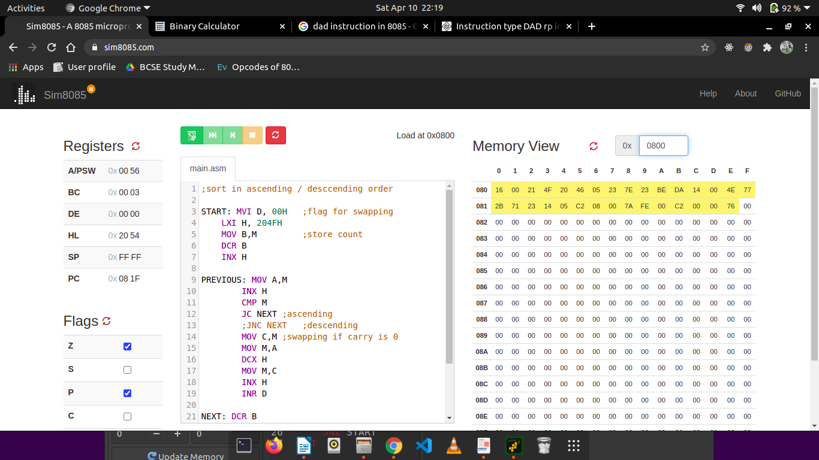
Sample input and output (M[204F] = 05H, M[2050] = 01H, M[2051] = 05H, M[2052] = 04H, M[2053] = 03H, M[2054] = 06H => M[2050] = 01H, M[2051] = 03H, M[2052] = 04H, M[2053] = 05H, M[2054] = 06H & M[2050] = 06H, M[2051] = 05H, M[2052] = 04H, M[2053] = 03H, M[2054] = 01H):
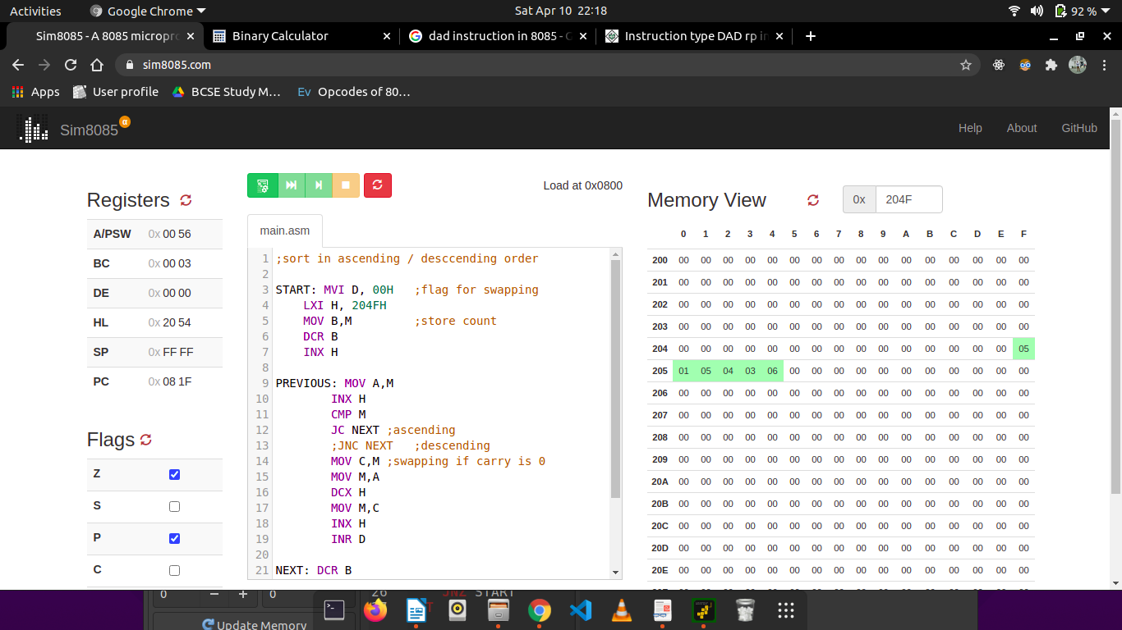

ASCENDING ORDER:

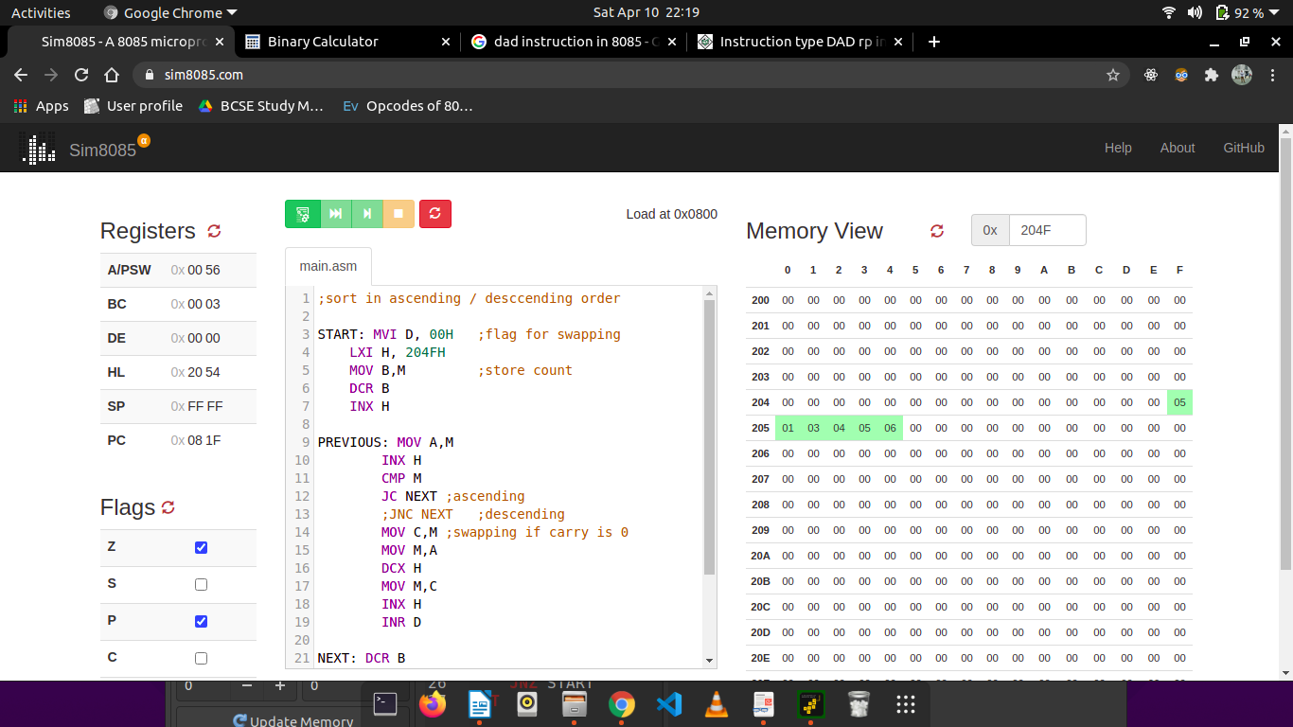

DESCENDING ORDER:

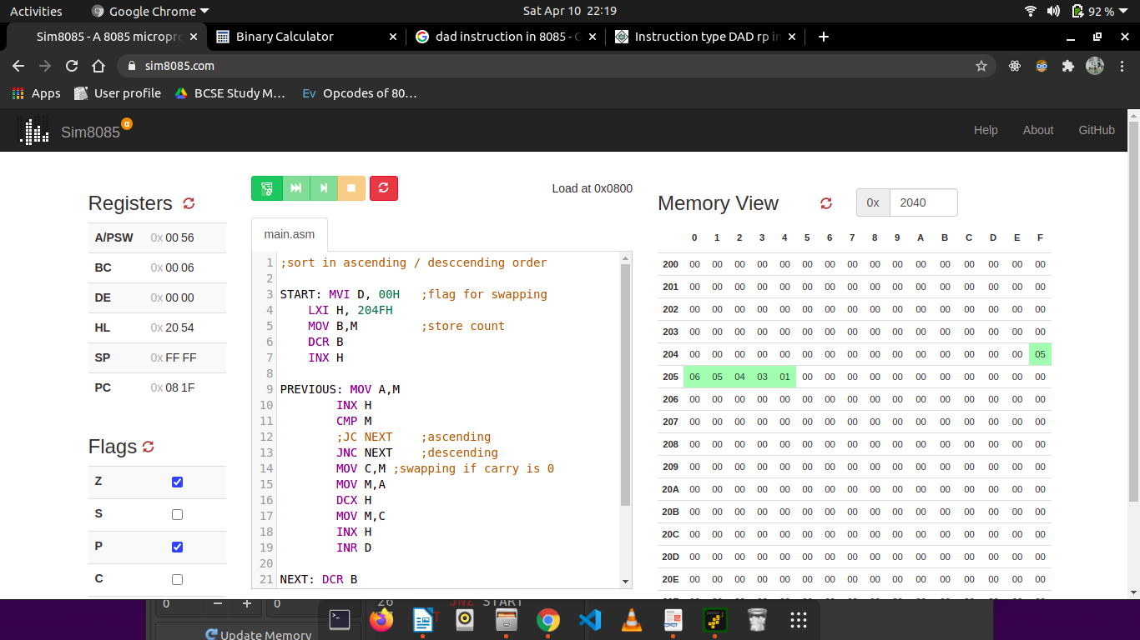

4. N numbers are stored in consecutive m/m location starting from 2050 H . The value N is stored in 204F H . Write a program to copy the even and odd numbers starting from 2100 H and 2200 H , respectively. Store the total no. of even and odd numbers in 2300 H and 2201 H respectively.

Line# | Address in Hex | Label | Instruction | Opcode in Hex | Remarks
1 | 0800 |  | LDA 204FH | 3A | Get the input N.
2 | 0801 |  | LDA 204FH | 4F | Get the input N.
3 | 0802 |  | LDA 204FH | 20 | Get the input N.
4 | 0803 |  | MOV C,A | 4F | C = A
5 | 0804 |  | MVI B, 00H | 06 | B = 0
6 | 0805 |  | MVI B, 00H | 00 | B = 0
7 | 0806 |  | LXI H, 2050H | 21 | Load the starting address of list
7 | 0807 |  | LXI H, 2050H | 50 | Load the starting address of list
7 | 0808 |  | LXI H, 2050H | 20 | Load the starting address of list
10 | 0809 |  | LXI D, 2100H | 11 | Load the address to store even numbers
10 | 080A |  | LXI D, 2100H | 00 | Load the address to store even numbers
10 | 080B |  | LXI D, 2100H | 21 | Load the address to store even numbers
13 | 080C |  | DCR C | 0D | C = C - 1
14 | 080D | START1 | MOV A,M | 7E | A = M
15 | 080E |  | ANI 01H | E6 | A = A AND 01H  IF A = 0, element is even
15 | 080F |  | ANI 01H | 01 | A = A AND 01H  IF A = 0, element is even
17 | 0810 |  | JZ EVEN | CA | Jump to EVEN if A = 0
18 | 0811 |  | JZ EVEN | 17 | Jump to EVEN if A = 0
19 | 0812 |  | JZ EVEN | 08 | Jump to EVEN if A = 0
20 | 0813 |  | MOV A,M | 7E | A = M
21 | 0814 |  | STAX D | 12 | Store A in register pair D
22 | 0815 |  | INX D | 13 | Go to next address
23 | 0816 |  | INR B | 04 | B = B + 1
24 | 0817 | EVEN | INX H | 23 | Go to next address
25 | 0818 |  | DCR C | 0D | C = C - 1
26 | 0819 |  | JNZ START1 | C2 | If C is not 0, repeat
26 | 081A |  | JNZ START1 | 0D | If C is not 0, repeat
26 | 081B |  | JNZ START1 | 08 | If C is not 0, repeat
29 | 081C |  | LDA 204FH | 3A | Get the input N.
29 | 081D |  | LDA 204FH | 4F | Get the input N.
29 | 081E |  | LDA 204FH | 20 | Get the input N.
30 | 081F |  | MOV C,A | 4F | C = A
31 | 0820 |  | LXI H, 2050H | 21 | Load the starting address of list
31 | 0821 |  | LXI H, 2050H | 50 | Load the starting address of list
31 | 0822 |  | LXI H, 2050H | 20 | Load the starting address of list
34 | 0823 |  | LXI D, 2200H | 11 | Load the address to store even numbers
34 | 0824 |  | LXI D, 2200H | 00 | Load the address to store even numbers
34 | 0825 |  | LXI D, 2200H | 22 | Load the address to store even numbers
37 | 0826 |  | DCR C | 0D | C = C - 1
38 | 0827 | START2 | MOV A,M | 7E | A = M
39 | 0828 |  | ANI 01H | E6 | A = A AND 01H  IF A = 1, element is even
39 | 0829 |  | ANI 01H | 01 | A = A AND 01H  IF A = 1, element is even
42 | 082A |  | JNZ ODD | C2 | Jump to ODD if A = 1
42 | 082B |  | JNZ ODD | 2C | Jump to ODD if A = 1
42 | 082C |  | JNZ ODD | 08 | Jump to ODD if A = 1
45 | 082D |  | MOV A,M | 7E | A = M
46 | 082E |  | STAX D | 12 | Store A in register pair D
47 | 082F |  | INX D | 13 | Go to next address
48 | 0830 | ODD | INX H | 23 | Go to next address in list
49 | 0831 |  | DCR C | 0D | C = C - 1
50 | 0832 |  | JNZ START2 | C2 | If C is not 0, repeat
50 | 0833 |  | JNZ START2 | 27 | If C is not 0, repeat
50 | 0834 |  | JNZ START2 | 08 | If C is not 0, repeat
53 | 0835 |  | MOV A,B | 78 | A = B //ccount of even numbes
54 | 0836 |  | STA 2301H | 32 | Store the count at required address.
54 | 0837 |  | STA 2301H | 01 | Store the count at required address.
54 | 0838 |  | STA 2301H | 23 | Store the count at required address.
57 | 0839 |  | LDA 204FH | 3A | Load the original N
57 | 083A |  | LDA 204FH | 4F | Load the original N
57 | 083B |  | LDA 204FH | 20 | Load the original N
60 | 083C |  | SUB B | 90 | A = A - B
61 | 083D |  | STA 2300H | 32 | Store the count at required address.
61 | 083E |  | STA 2300H | 00 | Store the count at required address.
61 | 083F |  | STA 2300H | 23 | Store the count at required address.
64 | 0840 |  | HLT | 76 | Halt

Simulator with loaded machine code:
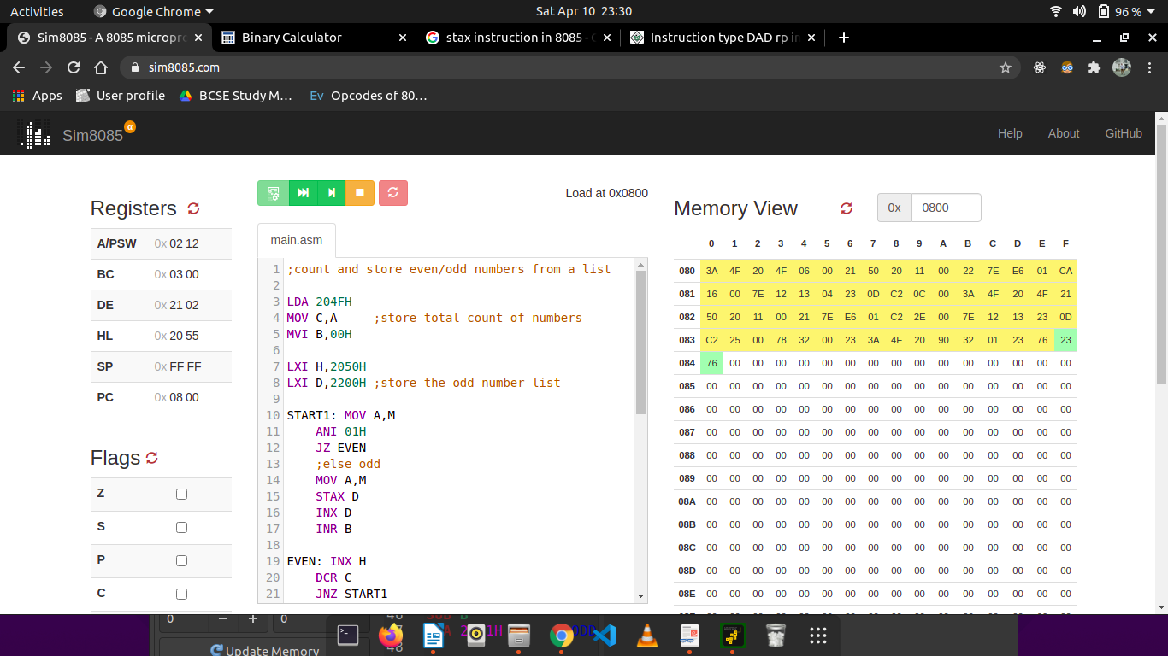

Sample input and output (M[204F] = 05H, M[2050] = 01H, M[2051] = 02H, M[2052] = 03H, M[2053] = 04H, M[2054] = 05H => M[2200] = 01H, M[2201] = 03H, M[2202] = 05H, M[2100] = 02H, M[2101] = 04H, M[2300] = 02H, M[2301] = 03H):

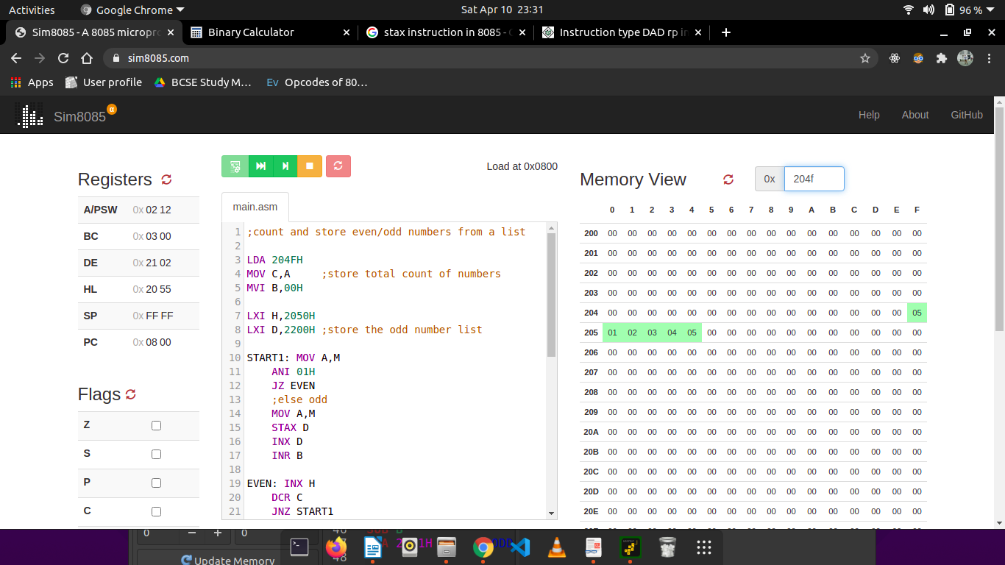
ODD NUMBERS:
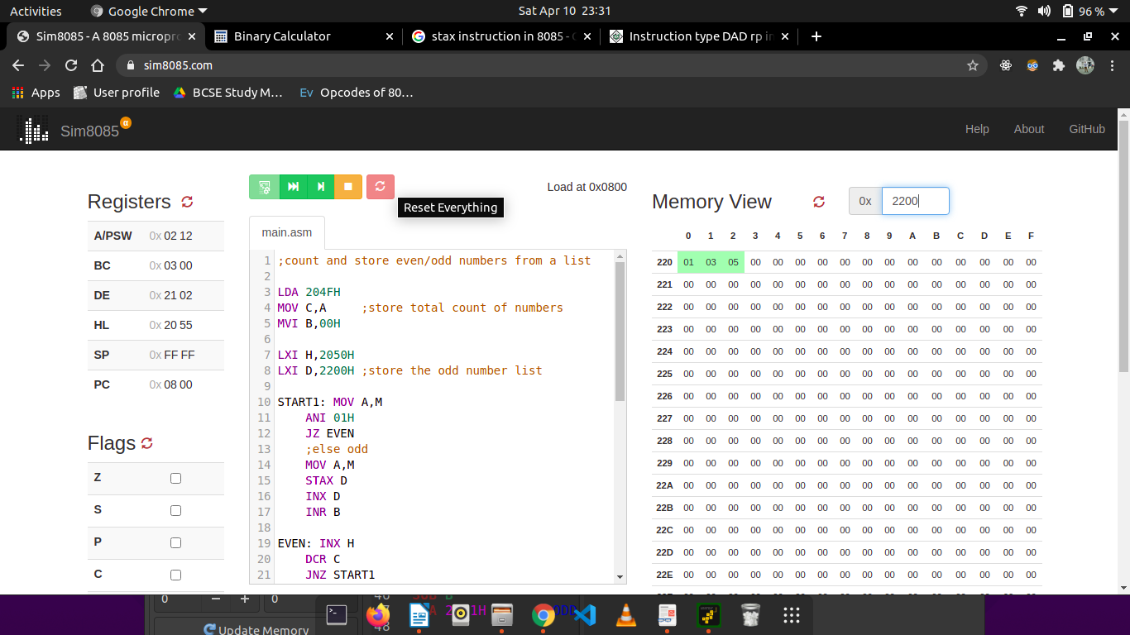

EVEN NUMBERS:

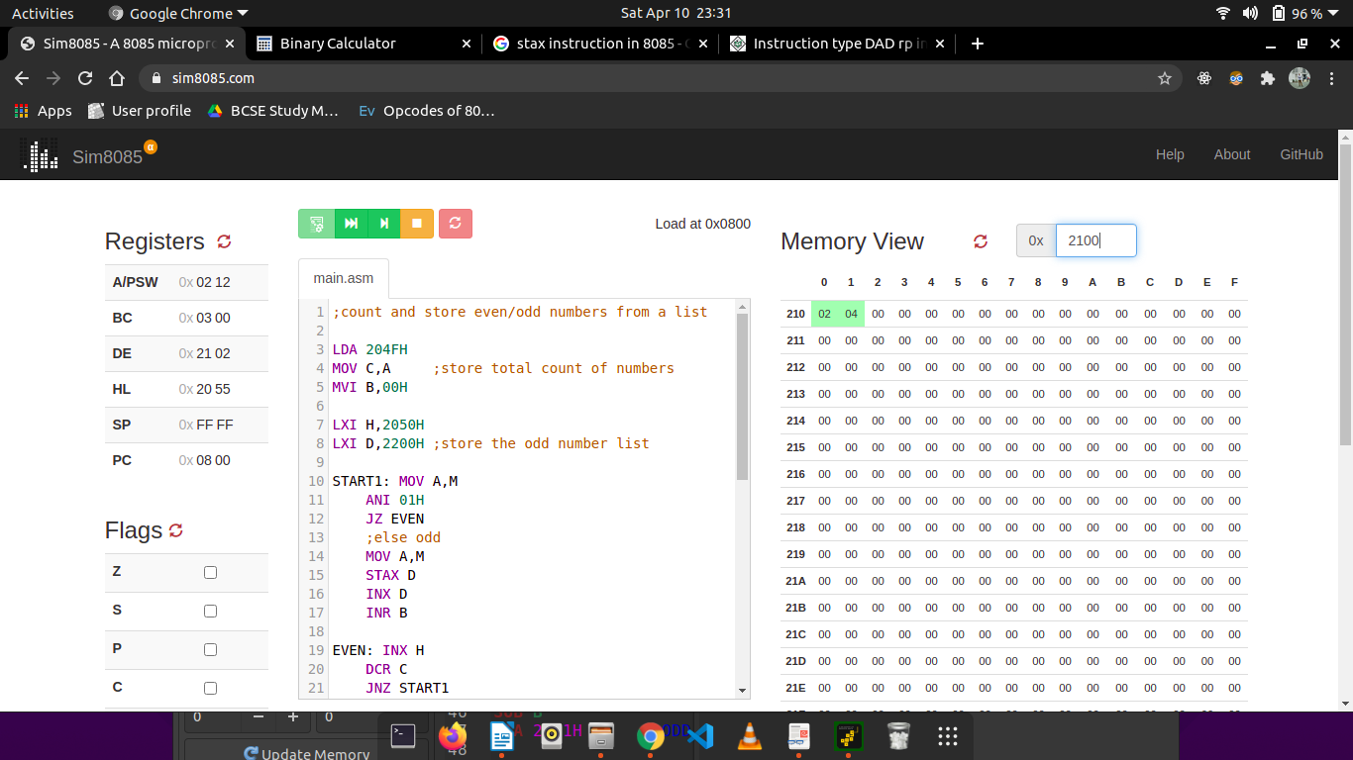

EVEN AND ODD COUNT:

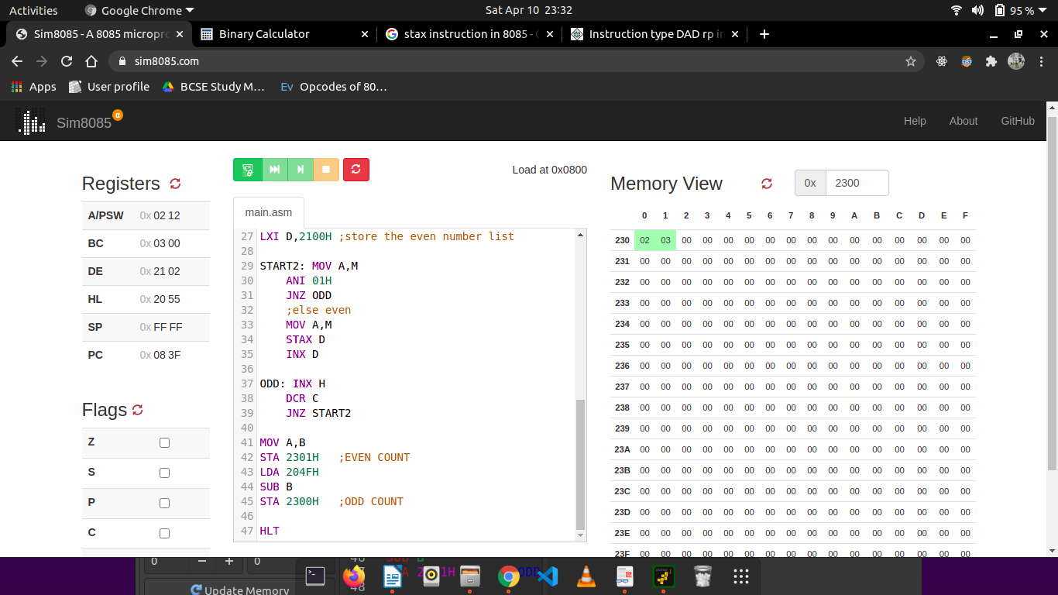

5. N numbers are stored in consecutive m/m location starting from 2050 H . The value N is stored in 204F H . Write a program to test whether a number stored in 204E H is present in the list. If present, store its position in the list at 204D H ; otherwise store FF H .

Line# | Address in Hex | Label | Instruction | Opcode in Hex | Remarks
1 | 0800 |  | LXI H,204FH | 21 | Get the input N
2 | 0801 |  | LXI H,204FH | 4F | Get the input N
3 | 0802 |  | LXI H,204FH | 20 | Get the input N
4 | 0803 |  | MOV C,M | 4E | C = M
5 | 0804 |  | MVI D, 01H | 16 | Store index of current element
6 | 0805 |  | MVI D, 01H | 01 | Store index of current element
7 | 0806 |  | LDA 204EH | 3A | Load the number to be searched.
7 | 0807 |  | LDA 204EH | 4E | Load the number to be searched.
7 | 0808 |  | LDA 204EH | 20 | Load the number to be searched.
10 | 0809 |  | MOV B,A | 47 | B = A
11 | 080A | REPEAT | INX H | 23 | Go to next address
12 | 080B |  | MOV A,M | 32 | A = M
13 | 080C |  | CMP B | B8 | A - B
14 | 080D |  | JNZ NEXT | C2 | Jump to NEXT if A is not equal to B.
14 | 080E |  | JNZ NEXT | 15 | Jump to NEXT if A is not equal to B.
14 | 080F |  | JNZ NEXT | 08 | Jump to NEXT if A is not equal to B.
15 | 0810 |  | MOV A,D | 7A | A = D
16 | 0811 |  | STA 204DH | 32 | Store index of number found
16 | 0812 |  | STA 204DH | 4D | Store index of number found
16 | 0813 |  | STA 204DH | 20 | Store index of number found
19 | 0814 |  | HLT | 76 | Halt
20 | 0815 | NEXT | MVI A, FFH | 3E | A = FFH
20 | 0816 | NEXT | MVI A, FFH | FF | A = FFH
22 | 0817 |  | STA 204DH | 32 | Store FF to indicate that number not found yet.
22 | 0818 |  | STA 204DH | 4D | Store FF to indicate that number not found yet.
22 | 0819 |  | STA 204DH | 20 | Store FF to indicate that number not found yet.
25 | 081A |  | INR D | 14 | D = D + 1
26 | 081B |  | DCR C | 0D | C = C - 1
27 | 081C |  | JNZ REPEAT | C2 | Jump to REPEAT until C = 0
27 | 081D |  | JNZ REPEAT | 0A | Jump to REPEAT until C = 0
27 | 081E |  | JNZ REPEAT | 08 | Jump to REPEAT until C = 0
28 | 081F |  | HLT | 76 | Halt

Simulator with loaded machine code:

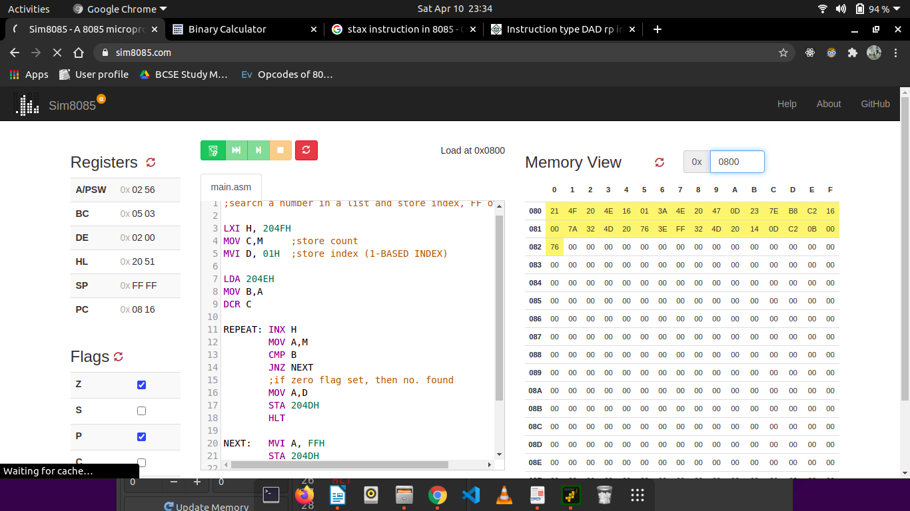

Sample input and output ( M[204F] = 05H, M[2050] = 01H, M[2051] = 05H, M[2052] = E0H, M[2053] = 08H, M[2054] = F0H, M[204E] = 05H => M[204D] = 02H):

